OFFICE OF THE HOLY OIL (SHORT FORM)
Served by one priest in case of necessity. A small table is prepared and on this is placed the Holy Gospel and a dish of wheat, and on the wheat an empty shrine lamp, and around it in the wheat seven wands wrapped with cotton wool for the anointing; and the Priest takes a lit taper. He stands in front of the table and is vested in the Phelonion. He takes the censer with incense and censes around the table of the oil and the whole Church, or the house, and the people, and standing in front of the table, facing East, he begins:
Blessed is our God, always now and for ever, and to the ages of ages.
People:
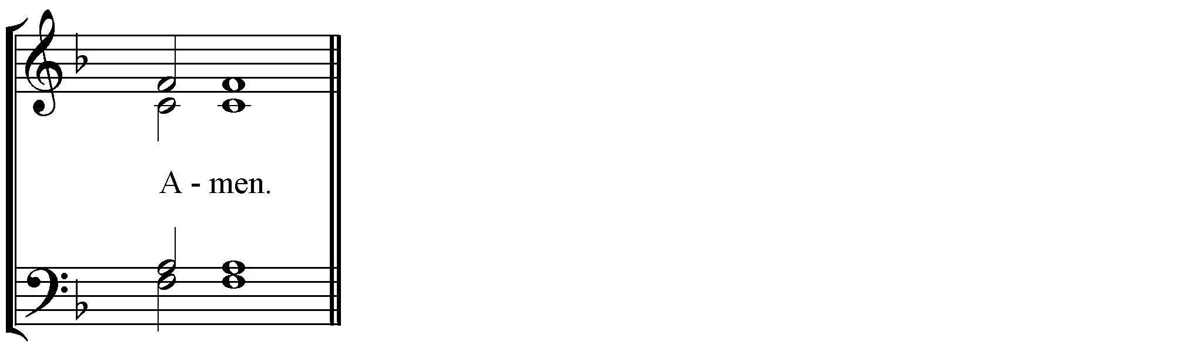.
Then the Deacon says the Litany:
In peace, let us pray to the Lord.
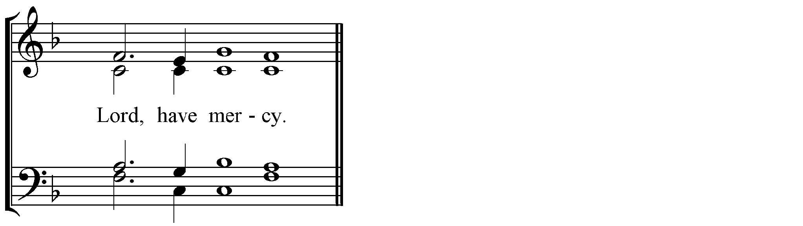
For the peace from on high and for the salvation of our souls, let us pray to the Lord.

People: Lord, have mercy.
For the peace of the whole world, for the welfare of the holy Churches of God, and for the union of all, let us pray to the Lord.
For this holy house, and for those who enter it with faith, reverence and the fear of God, let us pray to the Lord.
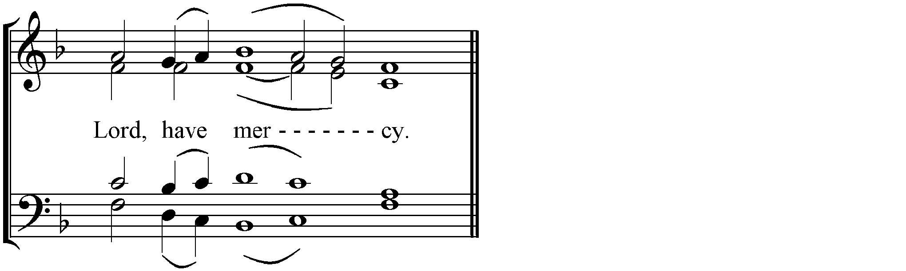
That this oil may be blessed by the power, operation and descent of the Holy Spirit, let us pray to the Lord.
For the servant of God, N., and for the visitation of God upon him/her, and that the grace of the Holy Spirit may come upon him/her, let us pray to the Lord.

For his/her and our deliverance from all affliction, wrath, danger and constraint, let us pray to the Lord.
Help us, save us, have mercy on us, and keep us, O God, by your grace.
Commemorating our all-holy, pure, most blessed and glorious Lady, Mother of God and Ever-Virgin Mary, with all the Saints, let us entrust ourselves and one another and our whole life to Christ our God.
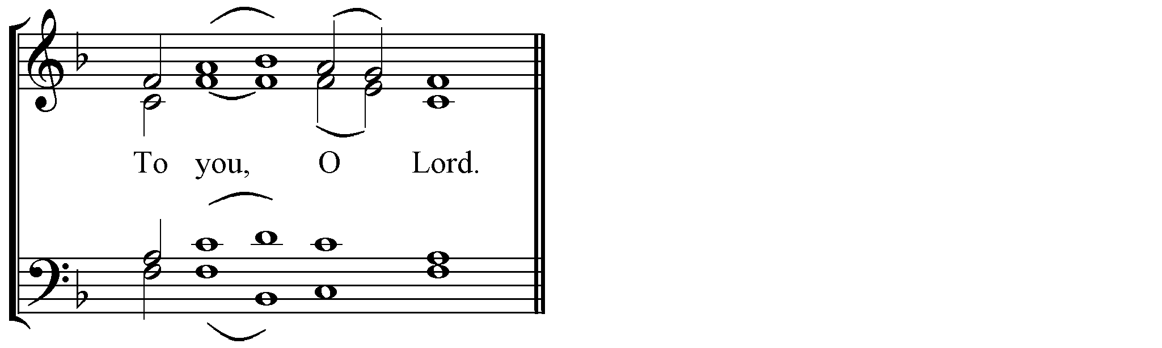

Then the Priest says the Prayer of the Oil in front of the lamp.
Deacon: Let us pray to the Lord.
Priest: O Lord, who in your mercy and pity heal the afflictions of our souls and bodies, sanctify this oil, O Master, so that it may be for those who are anointed with it for healing and relief of every passion, bodily disease, stain of flesh and spirit, and every evil; that through it your all-holy Name, of Father, Son, and Holy Spirit, may be glorified now and for ever, and to the ages of ages.
People:
Deacon: Let us attend.
Priest: Peace to all.
Reader: And to your spirit.
Deacon: Wisdom.
Reader, Prokeimenon. Tone 1. [Psalm 32]
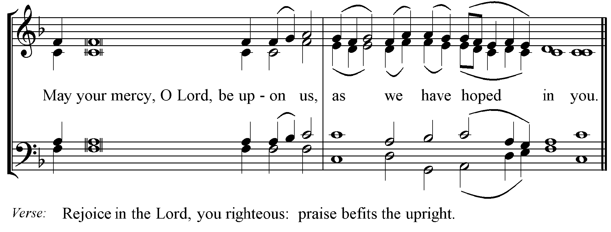
Deacon: Wisdom.
Reader: The Reading is from the General Epistle of the Holy Apostle James. [5:10-16]
Deacon: Let us attend.
The Deacon reads the lesson from the Apostle.
Brethren, as an example of suffering and patience take the prophets who spoke in the name of the Lord. Indeed we call blessed those who showed endurance. You have heard of the endurance of Job, and you have seen the purpose of the Lord, how the Lord is compassionate and merciful. Above all, my beloved, do not swear, either by heaven or by earth or by any other oath, but let your ‘Yes’ be yes and your ‘No’ be no, so that you may not fall under condemnation. Are any among you suffering? They should pray. Are any cheerful? They should sing songs of praise. Are any among you sick? They should call for the elders of the church and have them pray over them, anointing them with oil in the name of the Lord. The prayer of faith will save the sick, and the Lord will raise them up; and anyone who has committed sins will be forgiven. Therefore confess your sins to one another, and pray for one another, so that you may be healed. The prayer of the righteous is powerful and effective.
Priest: Peace to you.
Reader: And to your spirit.
Deacon: Wisdom.
Reader: Alleluia, alleluia, alleluia.
Alleluia. Tone 8. [Psalm 100]
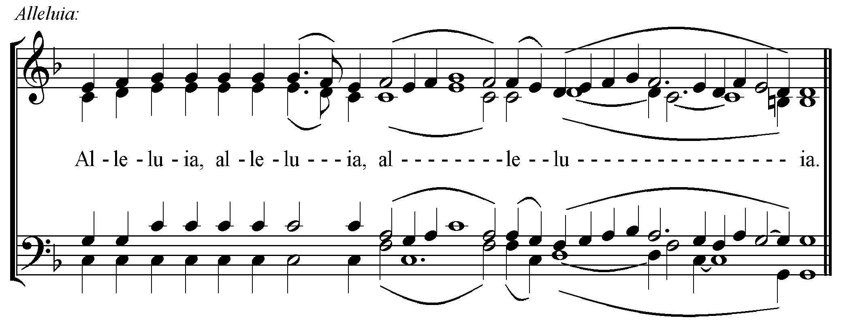
Verse: I will sing to you of mercy and judgement, O Lord.

Deacon: Wisdom. Stand upright. Let us listen to the Holy Gospel.
Priest: Peace to all.
People:
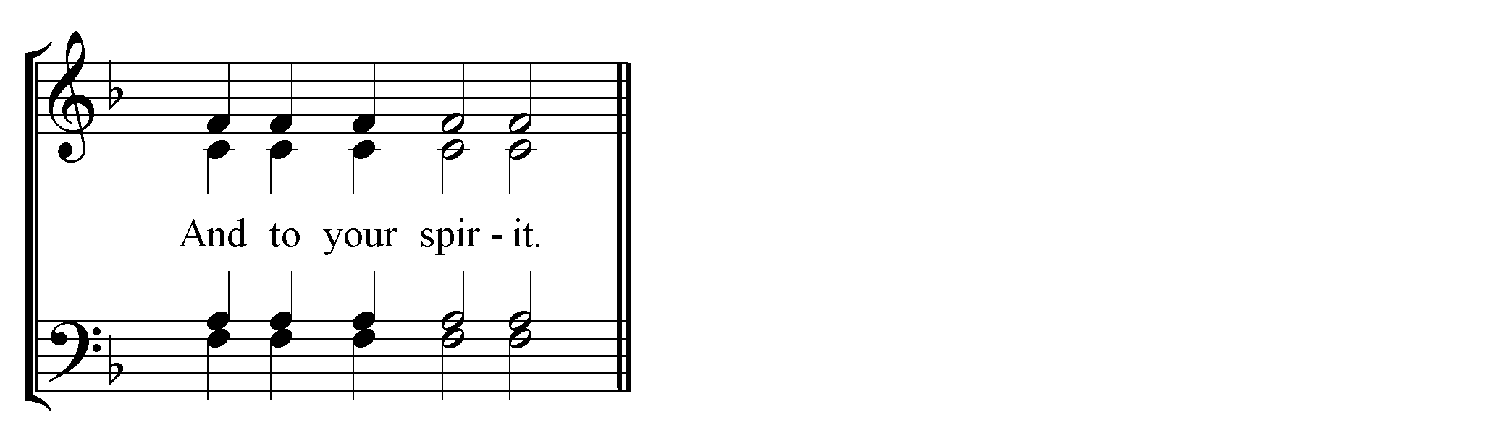
Priest: The Reading is from the Holy Gospel according to Luke. [10:25-37]
People:
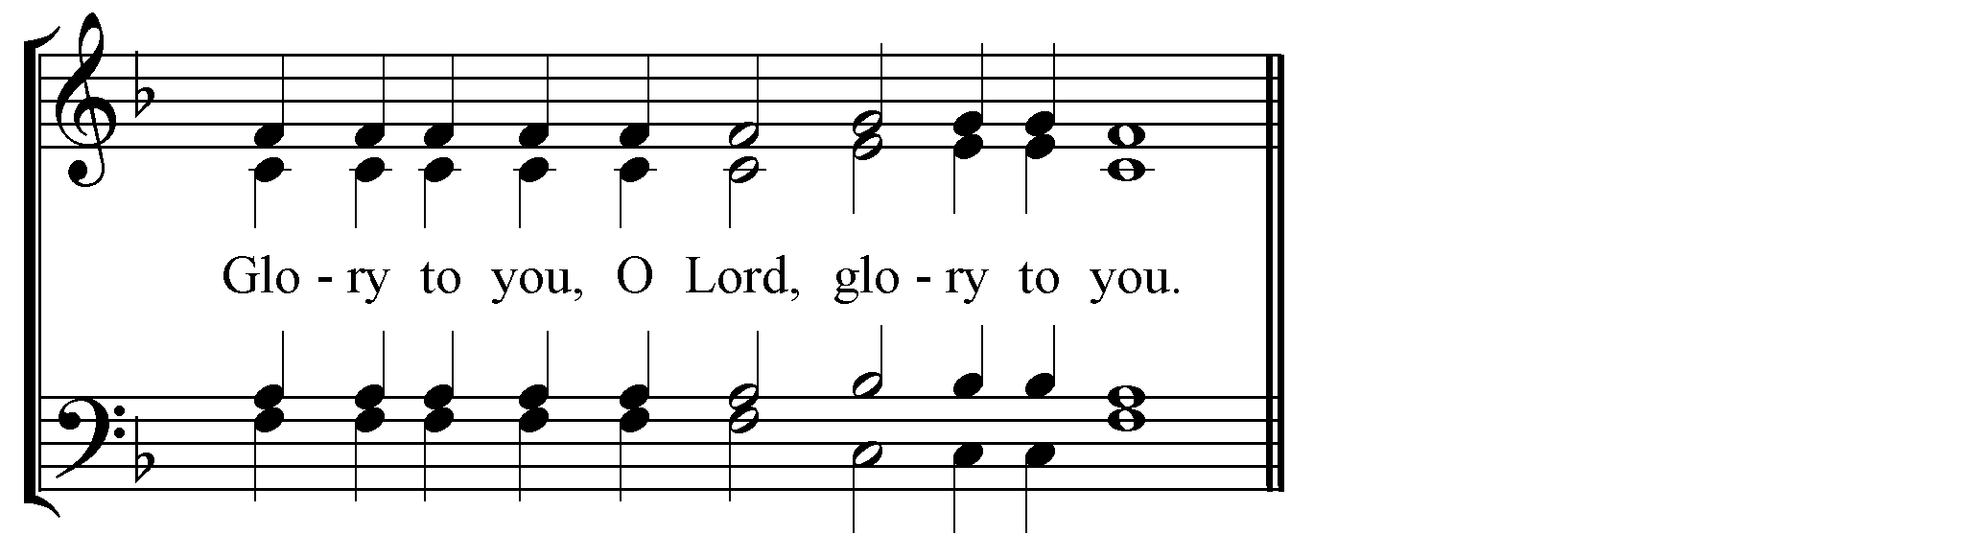

Deacon: Let us attend.
Priest:
At that time a lawyer stood up to test Jesus. ‘Teacher,’ he said, ‘what must I do to inherit eternal life?’ He said to him, ‘What is written in the law? What do you read there?’ He answered, ‘You shall love the Lord your God with all your heart, and with all your soul, and with all your strength, and with all your mind; and your neighbour as yourself.’ And he said to him, ‘You have given the right answer; do this, and you will live.’ But wanting to justify himself, he asked Jesus, ‘And who is my neighbour?’ Jesus replied, ‘A man was going down from Jerusalem to Jericho, and fell into the hands of robbers, who stripped him, beat him, and went away, leaving him half dead. Now by chance a priest was going down that road; and when he saw him, he passed by on the other side. So likewise a Levite, when he came to the place and saw him, passed by on the other side. But a Samaritan while travelling came near him; and when he saw him, he was moved with pity. He went to him and bandaged his wounds, having poured oil and wine on them. Then he put him on his own animal, brought him to an inn, and took care of him. The next day he took out two denarii, gave them to the innkeeper, and said, ‘Take care of him; and when I come back, I will repay you whatever more you spend’. Which of these three, do you think, was a neighbour to the man who fell into the hands of the robbers?’ He said, ‘The one who showed him mercy.’ Jesus said to him, ‘Go and do likewise.’
People:
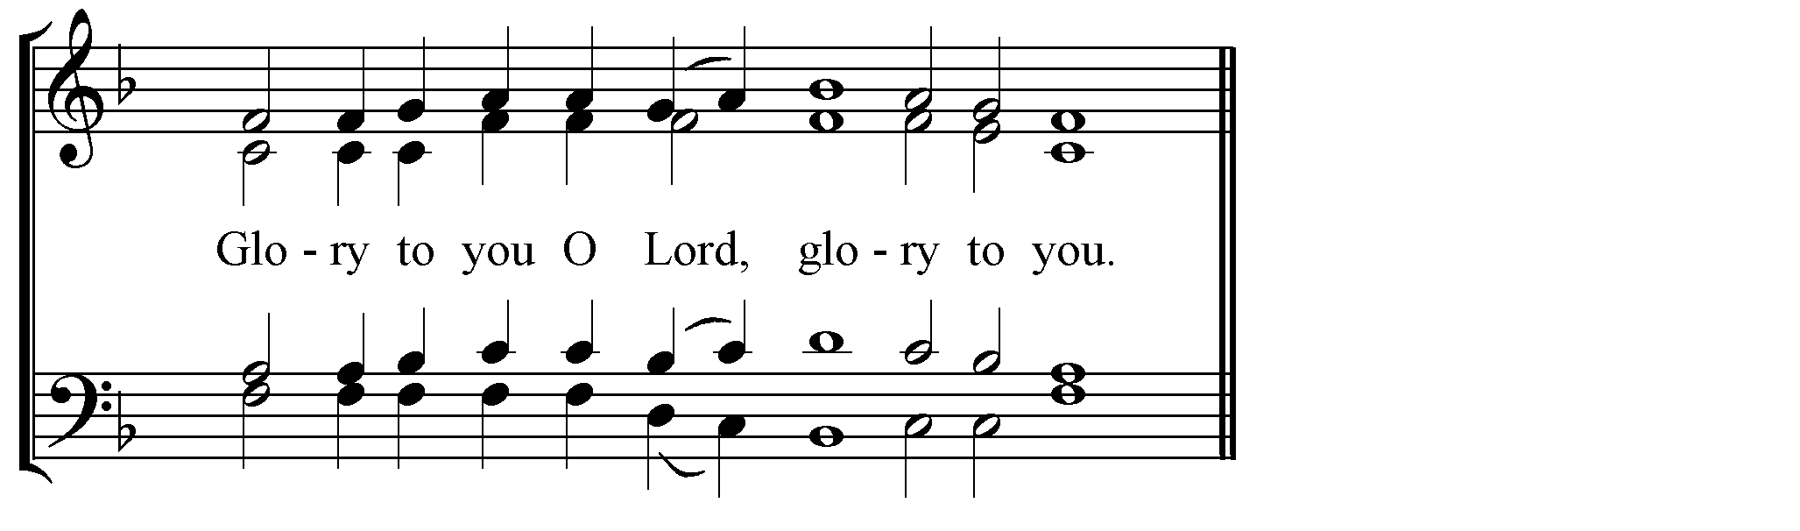
Then the Deacon:
Have mercy on us, O God, in accordance with your great mercy; we pray you hear and have mercy.
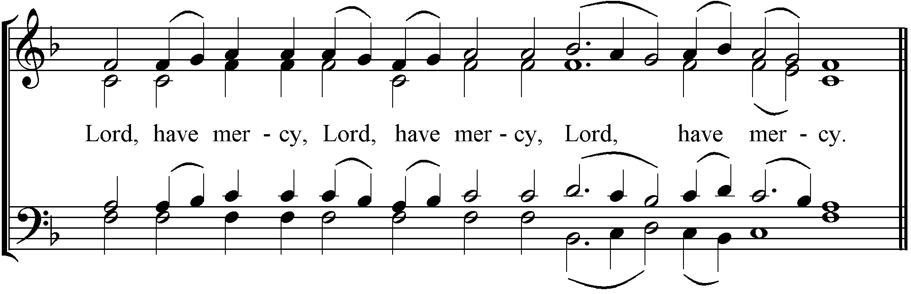
Also we pray for mercy, life, peace, health, salvation, visitation and forgiveness of sins for the servant(s) of God N. (here present).
That he (she, they) may be pardoned every offence both voluntary and involuntary, let us pray to the Lord.
Priest: For you, O God, are merciful and you love mankind, and to you we give glory, to the Father and to the Son and to the Holy Spirit, now and for ever, and to the ages of ages.
People:

Deacon: Let us pray to the Lord.
People:
The Priest says this Prayer:
O God without beginning and without end, Holy of Holies, who sent forth your Only-begotten Son to heal every disease and every weakness of our souls and bodies, send down your Holy Spirit and sanctify this oil; and cause it to be for your servant(s) who is (are) anointed for complete deliverance from his (her, their) sins, for inheritance of the Kingdom of heaven.
For you are God, great and wonderful, who keep your covenant and your mercy to those who love you. Through your holy child Jesus Christ you give deliverance from sins; you have given us new birth from sin, you give light to the blind, set upright those who are cast down; you love the righteous and are merciful to sinners; you have called us back from darkness and the shadow of death, saying to those in chains: ‘Come forth,’ and to those in darkness: ‘Reveal yourselves.’ For in our hearts has shone the light of the knowledge of your Only-begotten Son, since for us he appeared on earth and lived among men. And to as many as received him he gave power to become your children, O God, granting us the grace of sonship through the washing of rebirth, and causing us to have no part in the dominion of the devil. Since he did not consider it good for there to be cleansing by blood but by holy Oil, he has given us the sign of his Cross for us to become Christ’s flock, a royal priesthood, a holy nation, having purified us by water and sanctified us by the Holy Spirit. O Master and Lord, give grace for this your service, as you gave to Moses your servant, to Samuel your beloved, to John your chosen one, and to all those who in each generation have been well-pleasing to you. So make us also servants of the new Covenant of your Son for this oil, which you have made your own by your precious Blood, so that having put off worldly desires we may die to sin and live to righteousness, having put on our Lord Jesus Christ through the anointing of sanctification of the Oil which is about to be applied. May this oil, O Lord, be an oil of gladness, an oil of sanctification, a royal garment, a breastplate of power, a protection against every operation of the devil, an inviolable seal, joy of heart, eternal delight, so that all who are anointed with this oil of rebirth may become fearsome to their enemies and shine brightly with the brightness of your Saints, without spot or wrinkle, and may be received into your eternal rest and receive the prize of their high calling.
For yours it is to have mercy on us and to save us, O our God, and to you we give glory, together with your only-begotten Son , and your all-holy, good, and life-giving Spirit, now and for ever, and to the ages of ages.
People:
And after the Prayer the Priest takes one of the wands and, dipping it in the holy Oil, anoints the sick person crosswise, on the forehead, the nostrils, the cheeks, the lips, the breast, and on both sides of the hands, saying this Prayer:
Holy Father, physician of souls and bodies, who sent your Only-begotten Son our Lord Jesus Christ to heal every disease and to deliver from death, heal also your servants from the weakness of body and soul which holds them fast and give them life through the grace of your Son, at the prayers of our most holy Lady, Mother of God and ever-virgin Mary, by the might of the precious and life-giving Cross, at the protection of the honoured, heavenly and bodiless Powers, at the prayers of the honoured and glorious Prophet, Forerunner and Baptist John, of the holy, glorious and all-praised Apostles, of the holy, glorious and victorious Martyrs, of our venerable and God-bearing Fathers, of the holy and healing Unmercenaries Kosmas and Damian, Kyros and John, Panteleïmon and Hermolaos, Sampson and Diomedes, Mokios and Akinitos, Thalalaios and Tryphon, of the holy and righteous Forebears of God, Joachim and Anna, and of all the Saints.
For you are the source of healings, O our God, and to you we give glory, together with your only-begotten Son. and your consubstantial Spirit, now and for ever, and to the ages of ages.
People:
Then those who receive the Sacred Oil, if they are able, come to the Priest; or, supported by others, shall stand or sit. And the Priest takes the Holy Gospel and, opening it, places it with text downwards on the head of the sick person. The Priest does not lay on his hand, but says this Prayer out loud:
Deacon: Let us pray to the Lord.
People:
Priest:
Holy King, compassionate and most merciful Lord Jesus Christ, Son and Word of the living God, who do not desire the death of sinners, but that they turn back and live, I do not place my sinful hand on the heads of these who have approached you in sins and who ask from you through us forgiveness of sins, but stretch out your mighty and powerful hand in this holy Gospel, which is held upon the heads of your servants. And with them I beg and implore your compassionate love for mankind which does not remember evil. O God our Saviour, who through your Prophet Nathan granted forgiveness of his sins to David when he repented, and received Manasses’ prayer of repentance, may you yourself in your customary love for mankind accept these your servants who repent over their own offences, overlooking all their transgressions. For you are our God who commanded us to forgive seventy times seven those who fall into sins. Because as is your majesty so also is your mercy. And to you belong all glory, honour and worship, now and for ever, and to the ages of ages. Amen.
And taking the Gospel from the head(s) of the sick, he presents it to them to kiss.
And the Deacon says this Litany:
Have mercy on us, O God, in accordance with your great mercy; we pray you hear and have mercy.
Also we pray for mercy, life, peace, health, salvation, visitation and forgiveness of sins for the servants of God (here present).
That they may be pardoned every offence both voluntary and involuntary, let us pray to the Lord.
Priest: For you, O God, are merciful and you love mankind, and to you we give glory, to the Father and to the Son and to the Holy Spirit, now and for ever, and to the ages of ages.
People:
Priest: Glory to you, Christ God, our hope, glory to you.
People:
Glory to the Father, and to the Son, and to the Holy Spirit.
Both now and for ever, and to the ages of ages. Amen.
Lord, have mercy. Lord, have mercy. Lord, have mercy.
Holy Father, give the blessing.
And the Dismissal:
May Christ our true God, through the prayers of his Most Pure Mother; by the power of the precious and life-giving Cross; at the intercessions of the glorious and all-praised Apostle James, first Bishop of Jerusalem and Brother of God, and of all the Saints, save us and have mercy on us, for he is good and loves mankind.
Those who have received the sacred oil make a prostration and say:
Bless me, holy Fathers, and pardon me, a sinner. (Three times)
And having received their blessing and pardon they depart giving thanks to God.

